INSTRUCTIONS: This is an SOP template; it is complete when
1) All form fields have been completed to reflect chemical/lab-specific information, including adding relevant procedure information, or deleted inapplicable information; and
2) SOP has been signed and dated by the PI and relevant lab personnel.
Use safety data sheets (SDSs) as a resource for chemical-specific information. Text highlighted in gray indicates where information should be added or edited. Delete all instructions in red text and “Draft” watermark after the SOP is approved by PI.
Standard Operating Procedure
Chloroform

Section 1 – Lab-Specific Information
Building/Room(s) covered by this SOP:
Unit or department:
Principal Investigator Name:
Principal Investigator Signature/Date:

Section 2 – Hazards
REQUIRED -Identify the stock chemicals, intermediates, final compounds and wastes involved in your work.
Chloroform is a carcinogen. It is harmful if swallowed and causes skin irritation, serious eye irritation, and may cause drowsiness or dizziness. Chloroform is suspected of causing cancer and causing genetic defects of unborn children. It may cause damage to organs (liver, kidney) through prolonged or repeated exposure.
Exposure Limits:
OSHA PEL (8 HR. TWA): 2 ppm
OSHA Short Term Exposure Limit: 2 ppm
ACGIH TLV/TWA: 10 ppm
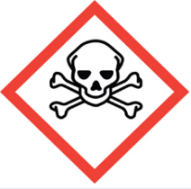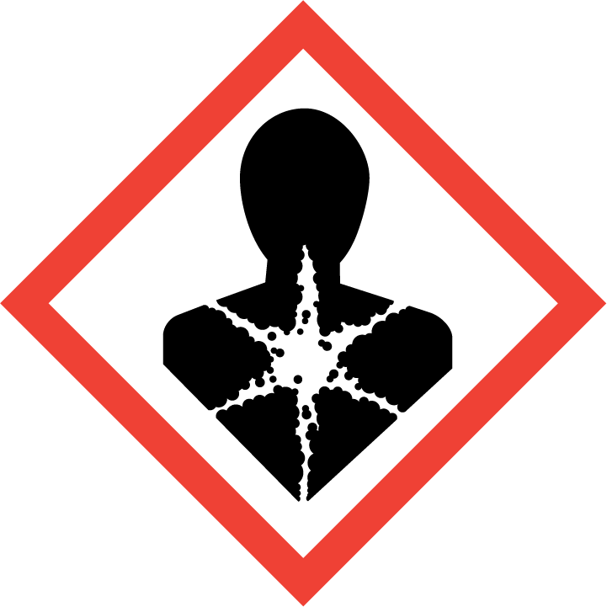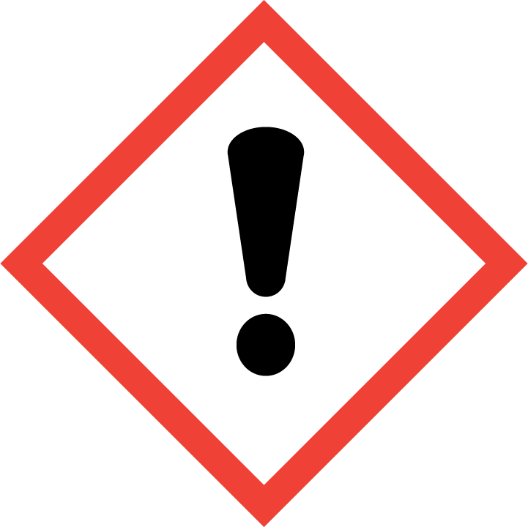

Section 3 – Environmental/Ventilation Controls
Contact UW EH&S at labcheck@uw.edu for engineering control details.
Engineering Controls: Use of chloroform should be conducted in a properly functioning chemical fume. The chemical fume hood must be tested and passed by EH&S.
REQUIRED - Insert descriptions of lab-specific engineering or ventilation controls used to reduce chemical exposures (e.g.,fume hoods, snorkels, glove boxes, reverse flow laminar benches, biosafety cabinets, etc.) or specific equipment safety features.
Hygiene Measures:
Avoid contact with skin, eyes, and clothing. Wash hands after removing PPE before breaks and immediately after handling the chemical. If chloroform come(s) into contact with any PPE, the PPE shall be immediately removed and discarded properly. Any potentially exposed body parts should be washed immediately. Wash hands before breaks and immediately after handling the product.
PPE must be specified completely, such as type, and whether necessary for the entire process or at certain steps. Refer to the chemical SDS(s) and UW Laboratory Safety Manual Section 5.b. for further guidance.
Skin and body protection. Chemically compatible laboratory coats that fully extend to the wrist must be worn and be appropriately sized for the individual and buttoned to their full length. Personnel must also wear full-length pants, or equivalent, and close-toe shoes. The area of skin between the shoe and ankle must not be exposed.
For chemicals that are toxic by skin contact/absorption additional protective clothing (e.g.,face shield, chemically-resistant apron, disposable sleeves, etc.) are required where splashes or skin contact is foreseeable.
REQUIRED: Specify type of lab coats to be used (if multiple options are available) or list information on chemical-appropriate alternatives, such as chemical aprons.
Hand protection. Hand protection is required for the activities described in this SOP.
Chemical-resistant gloves must be worn, nitrile gloves are recommended for low volume applications. Wearing two pairs of nitrile gloves is recommended. It is critical that the glove being worn is resistant to the specific chemical. Consult with your preferred glove manufacturer to ensure that the gloves you plan to use are compatible with the specific chemical being used.
REQUIRED - Insert the lab-specific gloves or glove combination that are required. When possible, include the exact manufacturer and model information.
Gloves must be inspected prior to use, including a check for pinholes.
Use proper glove removal technique (without touching glove's outer surface) to avoid skin contact with this product. Dispose of contaminated gloves after use in accordance with applicable laws and good laboratory practices. Wash and dry hands immediately after glove removal.
Eye Protection. ANSI Z87.1-compliant eye protection (safety glasses or chemical splash goggles) is required for all work with chloroform. A face shield may also be appropriate depending on the specific application. Ordinary prescription glasses will NOT provide adequate protection unless they also meet the Z87.1 standard and have compliant side shields.
REQUIRED - Specify minimum eye protection required (splash goggles, safety glasses, safety goggles, face shields).
Respiratory Protection:
REQUIRED - Specify if/when this chemical is allowed to be used outside of a fume hood and if additional respiratory protection is required for such work. Include expectations for completion of respirator fit-testing.
If chloroform is being used outside of a chemical fume hood, respiratory protection may be required. If this activity is necessary, contact EH&S Respiratory Protection Program Administrator to discuss respiratory protection or to enroll in the program.
Respirators should be used as a last line of defense (i.e., after engineering and administrative controls have been exhausted), and when any Action Limit (AL) or Occupational Exposure Limit (OEL) has been exceeded or when there is a possibility that an AL/OEL will be exceeded. Respiratory protection may be needed if dust, aerosol or vapor hazard is present and work is conducted outside of the fume hood. If any procedure may pose an external hazard it should be eliminated or strictly isolated. If a potential exposure hazard cannot be eliminated, contact EH&S Respiratory Protection Program Administrator to discuss respiratory protection or to enroll in the program so a respiratory protection analysis can be performed. Program enrollment includes medical evaluation, training and fit testing for an appropriate respirator. For information, see https://www.ehs.washington.edu/workplace/respiratory-protection, email uwresp@uw.edu, or call 206.616.3777. Where air-purifying respirators are appropriate, use a full-face respirator with appropriate respirator cartridges as a backup to engineering controls. Use a full-face supplied air respirator if it is the sole means of protection.
Section 4 – Special Handling and Storage Requirements
- Use in the smallest practical quantities for the experiment being performed.
- Avoid contact with skin and eyes and inhalation.
- Containers should be labeled appropriately. Label should indicate the name of the chemical(s) in the container. Avoid using chemical abbreviations and formulae.
- Containers should be in good condition and compatible with the material.
- Keep containers tightly closed.
- Store in a cool, dry and well-ventilated area away from incompatible substances such as oxidizers, metals and alkalis. For a more comprehensive list of incompatible chemical groups, refer to www.ehs.washington.edu/resource/incompatiblechemicals-focus-sheet-176.
- Containers which are opened must be carefully resealed and kept upright to prevent leakage.
- A suitable storage location is a flammable storage cabinet or lab cabinet that does not contain incompatibles.
- Clean the [specify ventilation control] upon completion of tasks with [specify cleaning solution]
- Clean all contaminated surfaces with [specify cleaning solution] and dry.
- Place all contaminated disposable items in appropriate laboratory waste for disposal.
- Non‐disposable/re‐usable utensils, glassware, and other surfaces contaminated with chloroform must be decontaminated at the end of the laboratory work session. Complete this inside [specify ventilation control] before removing any of the items.
- When work is completed, remove gloves and wash hands with soap and water.
REQUIRED - Insert descriptions of any additional administrative controls (e.g., restrictions on procedure/quantity/work equipment/work locations/unattended operations/etc.).
Users of chemicals are required to follow labeling requirements when transferring chemicals to secondary containers and when labeling containers with chemical waste. Requirements for labeling containers and templates for creating labels are available on the EH&S website.
Check Section 2 of the Lab Safety Manual and the Chemical Compatibility Chart on the EH&S website for incompatible chemical groups.
Special storage precautions may include keeping away from heat, light, air, flames, sources of ignition.
Check Section 2 of the Lab Safety Manual for information on chemical transport practices.

Section 5 – Spill and Accident Procedures
Personnel in this lab are only allowed to clean up spills inside the fume hood of [specify volume] or less using absorbent. Solvent absorption pads are stored [identify location of spill kit]. Do not attempt to clean up any spill if not trained or comfortable.
Clean the spill area thoroughly with detergent solution followed by clean water.
If spill is extensive within the containment, clean all interior surfaces after completion of the spill cleanup.
Double bag all waste in plastic bags labeled with a hazardous waste label that reads "chloroform spill debris." Complete either an Online Chemical Waste Collection Request or a Chemical Collection Request Form found on the EH&S website. Email the form to chmwaste@uw.edu
For spills outside the fume hood or larger spills, vapors generated may be above the chloroform exposure limits. Therefore ,these spills may require the use of respiratory protection. Cover spill if possible to keep vapors down. Evacuate the laboratory, prevent re-entry by un-authorized personnel, and call 911 from a campus phone, or the EH&S spills line at 206-543-0467 for help. If it is after hours, call 911 for further assistance. Tell them a chloroform spill has occurred. If the spill is out of control, call 911. If a person is injured, exposed or suspected of being exposed, call 911.
Any spill incident requires the involved person or supervisor to complete and submit the Online Accident Reporting System (OARS) form within 24 hours (certain types of incidents require immediate notification) of the incident to EH&S. For questions on spill cleanup, contact EH&S spill consultants at 206‐543‐0467.
REQUIRED - Insert descriptions of any specialized spill clean up procedures for materials used in this SOP. Additional details of lab-specific spill cleanup should be provided if applicable.
Describe how spills or accidental releases should be handled and by whom.
Clean up spills using contents of the laboratory spill kit: [describe specific types of spill clean-up materials required].
Specify any signage, entry restrictions that are required.
Describe PPE required for cleanup.
Exposures: If a person is injured, exposed, or suspected of being exposed to chloroform, follow procedures listed here:
INSERT IF APPLICABLE - Descriptions of any specialized emergency procedures for locations outside of a UW campus or facility.
Perform first aid immediately.
Refer to SDS for additional chemical-specific guidance; include pertinent information here.
- Inhalation exposure: Move out of contaminated area; get medical help.
- Sharps injury (needle stick or subcutaneous exposure): Scrub exposed area thoroughly for 15 minutes using warm water and sudsing soap.
- Skin exposure: Use the nearest safety shower for 15 minutes; stay under the shower and remove clothing; use a clean lab coat or spare clothing for cover‐up.
- Eye exposure: Use the eye wash for 15 minutes while holding eyelids open.
Get Help.
- Call 9-1-1 or go to nearest Emergency Department (ED); provide details of exposure:
    - Agent
    - Dose
    - Route of exposure
    - Time since exposure
- Bring the SDS and this SOP to the Emergency Department
- Notify your supervisor as soon as possible for assistance
- Secure the area before leaving; lock doors and indicate spill if needed
Report the incident to Environmental Health & Safety.
- Notify EH&S immediately after providing first aid and/or getting help.
  - During business hours (M‐F/8‐5), call 206‐543‐7262.
  - Outside of business hours, call 206‐685‐UWPD (8973) to be routed to EH&S Staff On Call.
- The involved person or supervisor submits the UW Online Accident Reporting System (OARS) form on the EH&S website within 24 hours (certain types of incidents require immediate notification) at oars.ehs.washington.edu.
Section 6 – Waste accumulation and disposal procedures
REQUIRED - Describe specific waste disposal procedures for all waste streams generated with chloroform. Include appropriate containment practices, storage locations, and any specific storage or handling practices. If relevant, include instructions for updating chemical inventories.
Refer to the SDS and UW Laboratory Safety Manual, Section 3 for guidance on waste handling, labeling, accumulation, storage and pickup.
Per UW Administrative Policy Statement 11.2, the University of Washington Environmental Health & Safety Department has full responsibility for collection of hazardous waste for the University, all its campuses, and off-site locations; University laboratories cannot contract with an outside vendor to collect hazardous waste.
Be aware that many laboratory accidents happen from inadvertent disposal of incompatible wastes into the same waste container. Therefore, identify different waste streams as appropriate.
Accumulate waste at the point of generation in a sturdy, [compatible container], with a securely-closable/screw‐top lid.
Vented lids may be appropriate for certain chemicals. Email labcheck@uw.edu with questions.
Manage chemical and hazardous chemical waste separately from other waste streams such as biohazardous waste. Never autoclave chemical waste because it can produce hazardous chemical vapors, aerosols, and explosive reactions.
All chemical waste containers must be labeled with a UW Hazardous Waste Label. Refer to How to Label Chemical Waste Containers.
To request a collection of chemical waste, submit a form on the Chemical Waste Disposal webpage on the EH&S website or directly in MyChem inventory. Contact EH&S at 206.616.5835 or chmwaste@uw.edu with questions.
Work area decontamination procedures as appropriate for the chemical in use should be followed.
REQUIRED - Insert descriptions of decontamination procedures for equipment, glassware, and controlled areas (e.g., glove boxes, restricted access hoods, perchloric/hot acid fume hoods, or designated portions of the laboratory) where this/these chemical(s) is/are used.
Visit the Hazardous Material Disposal and Recycling webpage on the EH&S website for information on disposing, recycling and surplusing materials.

Section 7 – Process/Protocol
REQUIRED - Insert or attach detailed laboratory-specific procedures for the process, hazardous chemical(s), or hazard class. You may also include any relevant supporting resources such as journal citations, etc. that are applicable.
Refer to Section 2 of the UW Laboratory Safety Manual on the EH&S website for additional guidance on chemical management.
NOTE: Any deviation from this SOP requires approval from Principal Investigator.

Section 8 – Special Precautions for Animal Use (___Yes ___No)
Use of chloroform in animals will be documented and approved by IACUC.
Annotate “N/A” if no animal exposure is involved. If chemicals are being administered to animals, describe how employees should protect themselves from contaminated animals and animal waste. Include all restricted access, chemical administration, aerosol suppression, PPE, and waste disposal procedures required.
Describe how employees should protect themselves from contaminated animals and animal waste.

PARTICULARLY HAZARDOUS SUBSTANCE INVOLVED? | YES: | Sections #9 to #11 are Mandatory
 | NO: | Sections #9 to #11 are Optional.
EH&S flags Particularly Hazardous Chemicals in MyChem based on hazards.

Section 9 – Approvals required
All staff working with chloroform must be trained on this SOP prior to starting work. They must also review the [chemical] SDS, and it must be readily available in the laboratory. All training must be documented and maintained by the PI or their designee.
Describe any requirements for obtaining authorization before use of the chemical for the procedure, operation, or activity can be performed.
Examples:
- A worker must have [specific training] documented before performing described procedure for the first time.
- Other authorizations required before a person can independently perform a process using chloroform.

Section 10 – Decontamination
Include work area decontamination procedures as appropriate for the chemical in use:
REQUIRED - Insert descriptions of decontamination procedures for equipment, glassware, controlled areas (e.g., glove boxes, restricted access hoods, perchloric/hot acid fume hoods, designated laboratory areas), include cleaning solutions and materials.

Section 11 – Designated area

REQUIRED - Identify specific areas where the particularly hazardous chemicals may be used (e.g., glove boxes, restricted access hoods, perchloric/hot acid fume hoods, or designated portions of the laboratory).

Section 12 – Documentation of training (signature of all users is required)
- Prior to using substances included in this SOP, laboratory personnel must be trained on the hazards described in this SOP, how to protect themselves from the hazards, and emergency procedures.
- Ready access to this SOP and to a Safety Data Sheet for each hazardous material described in the SOP must be made available in the lab space(s) where these substances are used.
- The Principal Investigator (PI), or Responsible Party, if the activity does not involve a PI, must ensure that their laboratory personnel have attended appropriate laboratory safety training (and refresher training where applicable).
- Training must be repeated following any revision to the content of this SOP.
- Training must be documented. This training sheet is provided as one option; other forms of training documentation (including electronic) are acceptable but records must be accessible and immediately available upon request.
I have read and understand the content of this SOP:
Name | Signature | Date

